Integrazione archivi Metodo ⬄Dossier Manager

Gli archivi che vengono esportati da Metodo a Dossier Manager sono:

* Clienti e Fornitori: Tutti
* Articoli: vengono esportati a Dossier Manager solamente quelli il cui gruppo di appartenenza contiene il valore DM nella colonna note:

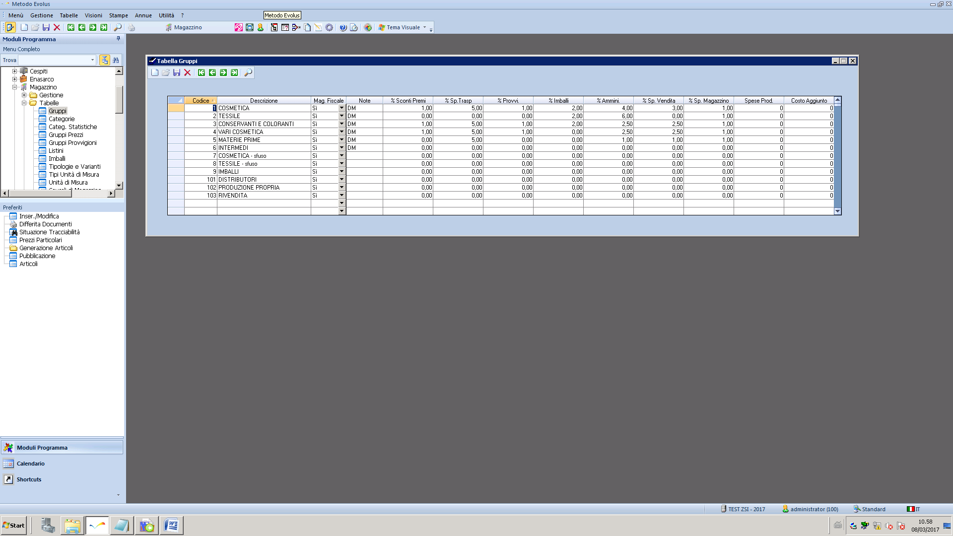

Il job è schedulato sul server database. Si chiama EXP_DOSSIERMANAGER e lancia la seguente store procedure: ITA_EXP_DOSSIERMANAGER. E’ schedulato nella maniera seguente:

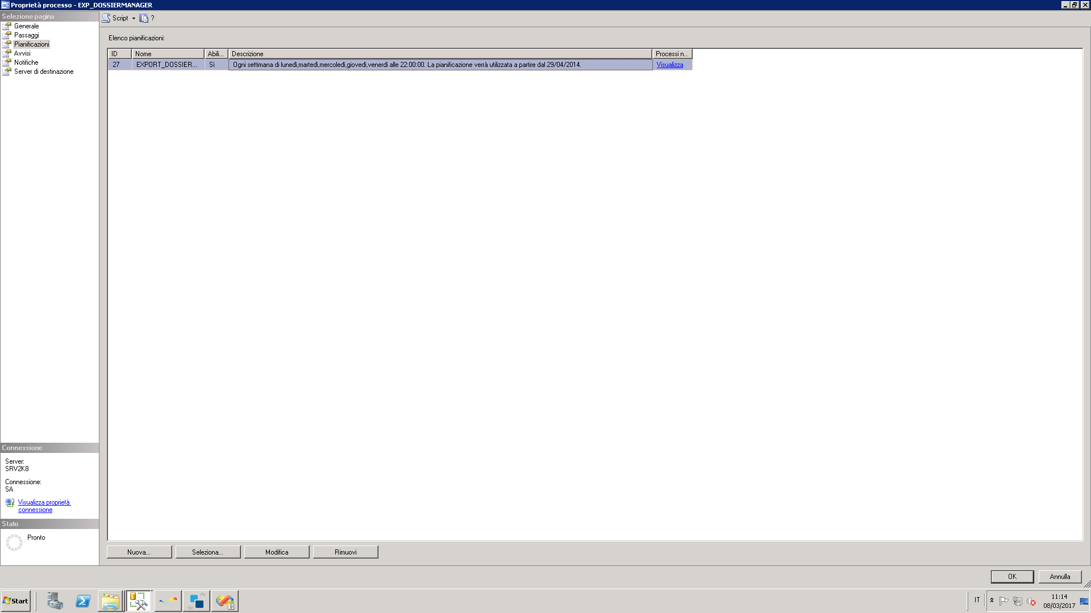

Script di creazione del job :

USE [msdb]

GO

/****** Object: Job [EXP_DOSSIERMANAGER] Script Date: 03/08/2017 11:10:59 ******/

IF EXISTS (SELECT job_id FROM msdb.dbo.sysjobs_view WHERE name = N'EXP_DOSSIERMANAGER')

EXEC msdb.dbo.sp_delete_job @job_id=N'e877159f-7a97-46c4-9a41-f99f14a3009c', @delete_unused_schedule=1

GO

USE [msdb]

GO

/****** Object: Job [EXP_DOSSIERMANAGER] Script Date: 03/08/2017 11:10:59 ******/

BEGIN TRANSACTION

DECLARE @ReturnCode INT

SELECT @ReturnCode = 0

/****** Object: JobCategory [[Uncategorized (Local)]]] Script Date: 03/08/2017 11:10:59 ******/

IF NOT EXISTS (SELECT name FROM msdb.dbo.syscategories WHERE name=N'[Uncategorized (Local)]' AND category_class=1)

BEGIN

EXEC @ReturnCode = msdb.dbo.sp_add_category @class=N'JOB', @type=N'LOCAL', @name=N'[Uncategorized (Local)]'

IF (@@ERROR <> 0 OR @ReturnCode <> 0) GOTO QuitWithRollback

END

DECLARE @jobId BINARY(16)

EXEC @ReturnCode = msdb.dbo.sp_add_job @job_name=N'EXP_DOSSIERMANAGER',

@enabled=1,

@notify_level_eventlog=3,

@notify_level_email=0,

@notify_level_netsend=0,

@notify_level_page=0,

@delete_level=0,

@description=N'ESPORTAZIONE VERSO DOSSIER MANAGER',

@category_name=N'[Uncategorized (Local)]',

@owner_login_name=N'sa', @job_id = @jobId OUTPUT

IF (@@ERROR <> 0 OR @ReturnCode <> 0) GOTO QuitWithRollback

/****** Object: Step [EXPORT] Script Date: 03/08/2017 11:10:59 ******/

EXEC @ReturnCode = msdb.dbo.sp_add_jobstep @job_id=@jobId, @step_name=N'EXPORT',

@step_id=1,

@cmdexec_success_code=0,

@on_success_action=1,

@on_success_step_id=0,

@on_fail_action=2,

@on_fail_step_id=0,

@retry_attempts=0,

@retry_interval=0,

@os_run_priority=0, @subsystem=N'TSQL',

@command=N'EXEC ITA_EXP_DOSSIERMANAGER',

@database_name=N'ZSI',

@flags=0

IF (@@ERROR <> 0 OR @ReturnCode <> 0) GOTO QuitWithRollback

EXEC @ReturnCode = msdb.dbo.sp_update_job @job_id = @jobId, @start_step_id = 1

IF (@@ERROR <> 0 OR @ReturnCode <> 0) GOTO QuitWithRollback

EXEC @ReturnCode = msdb.dbo.sp_add_jobschedule @job_id=@jobId, @name=N'EXPORT_DOSSIERMANAGER',

@enabled=1,

@freq_type=8,

@freq_interval=62,

@freq_subday_type=1,

@freq_subday_interval=0,

@freq_relative_interval=0,

@freq_recurrence_factor=1,

@active_start_date=20140429,

@active_end_date=99991231,

@active_start_time=220000,

@active_end_time=235959,

@schedule_uid=N'c448db0c-54fb-4108-aaa6-c5b502c6ad02'

IF (@@ERROR <> 0 OR @ReturnCode <> 0) GOTO QuitWithRollback

EXEC @ReturnCode = msdb.dbo.sp_add_jobserver @job_id = @jobId, @server_name = N'(local)'

IF (@@ERROR <> 0 OR @ReturnCode <> 0) GOTO QuitWithRollback

COMMIT TRANSACTION

GOTO EndSave

QuitWithRollback:

IF (@@TRANCOUNT > 0) ROLLBACK TRANSACTION

EndSave:

GO